**Name:** Rohit Maheshwari **SID:**012423918

**Assignment:** HTML Page Scrapping – jQuery & USDA Food Composition Databases

**Prerequisite:** Enable cross-origin resource sharing is enabled in the web browser

**Working:**

After clicking the button, web-app is scrapping data using JavaScript and jQuery from the given url: <https://ndb.nal.usda.gov/ndb/search/lis>

Data is then converted into JS object and finally stored in the DB table (Screenshot 3).

**Initial Screen:**

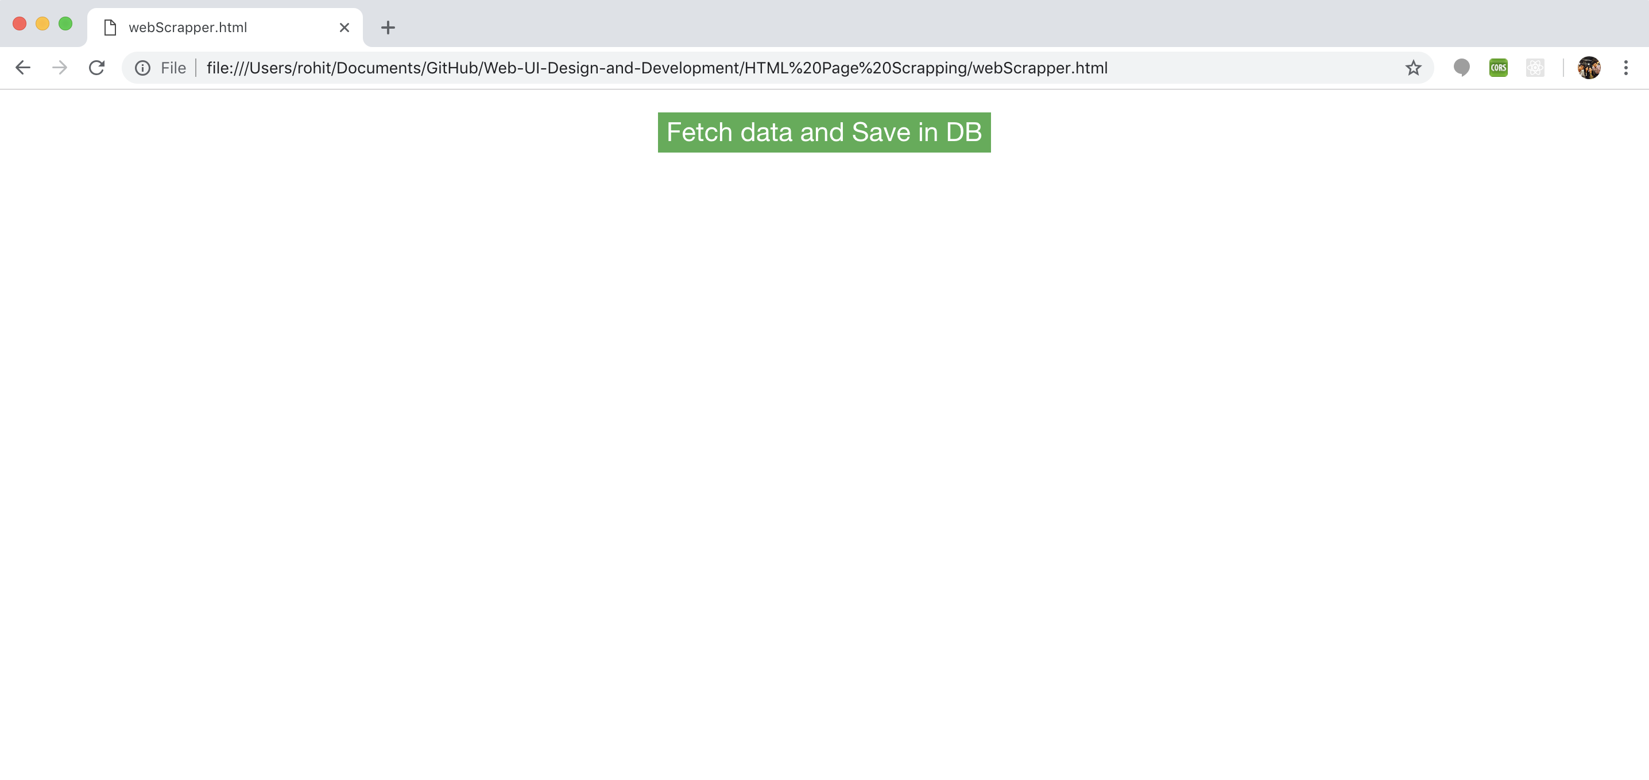

**After Clicking Button (Fetched data is also shown in screen as table):**

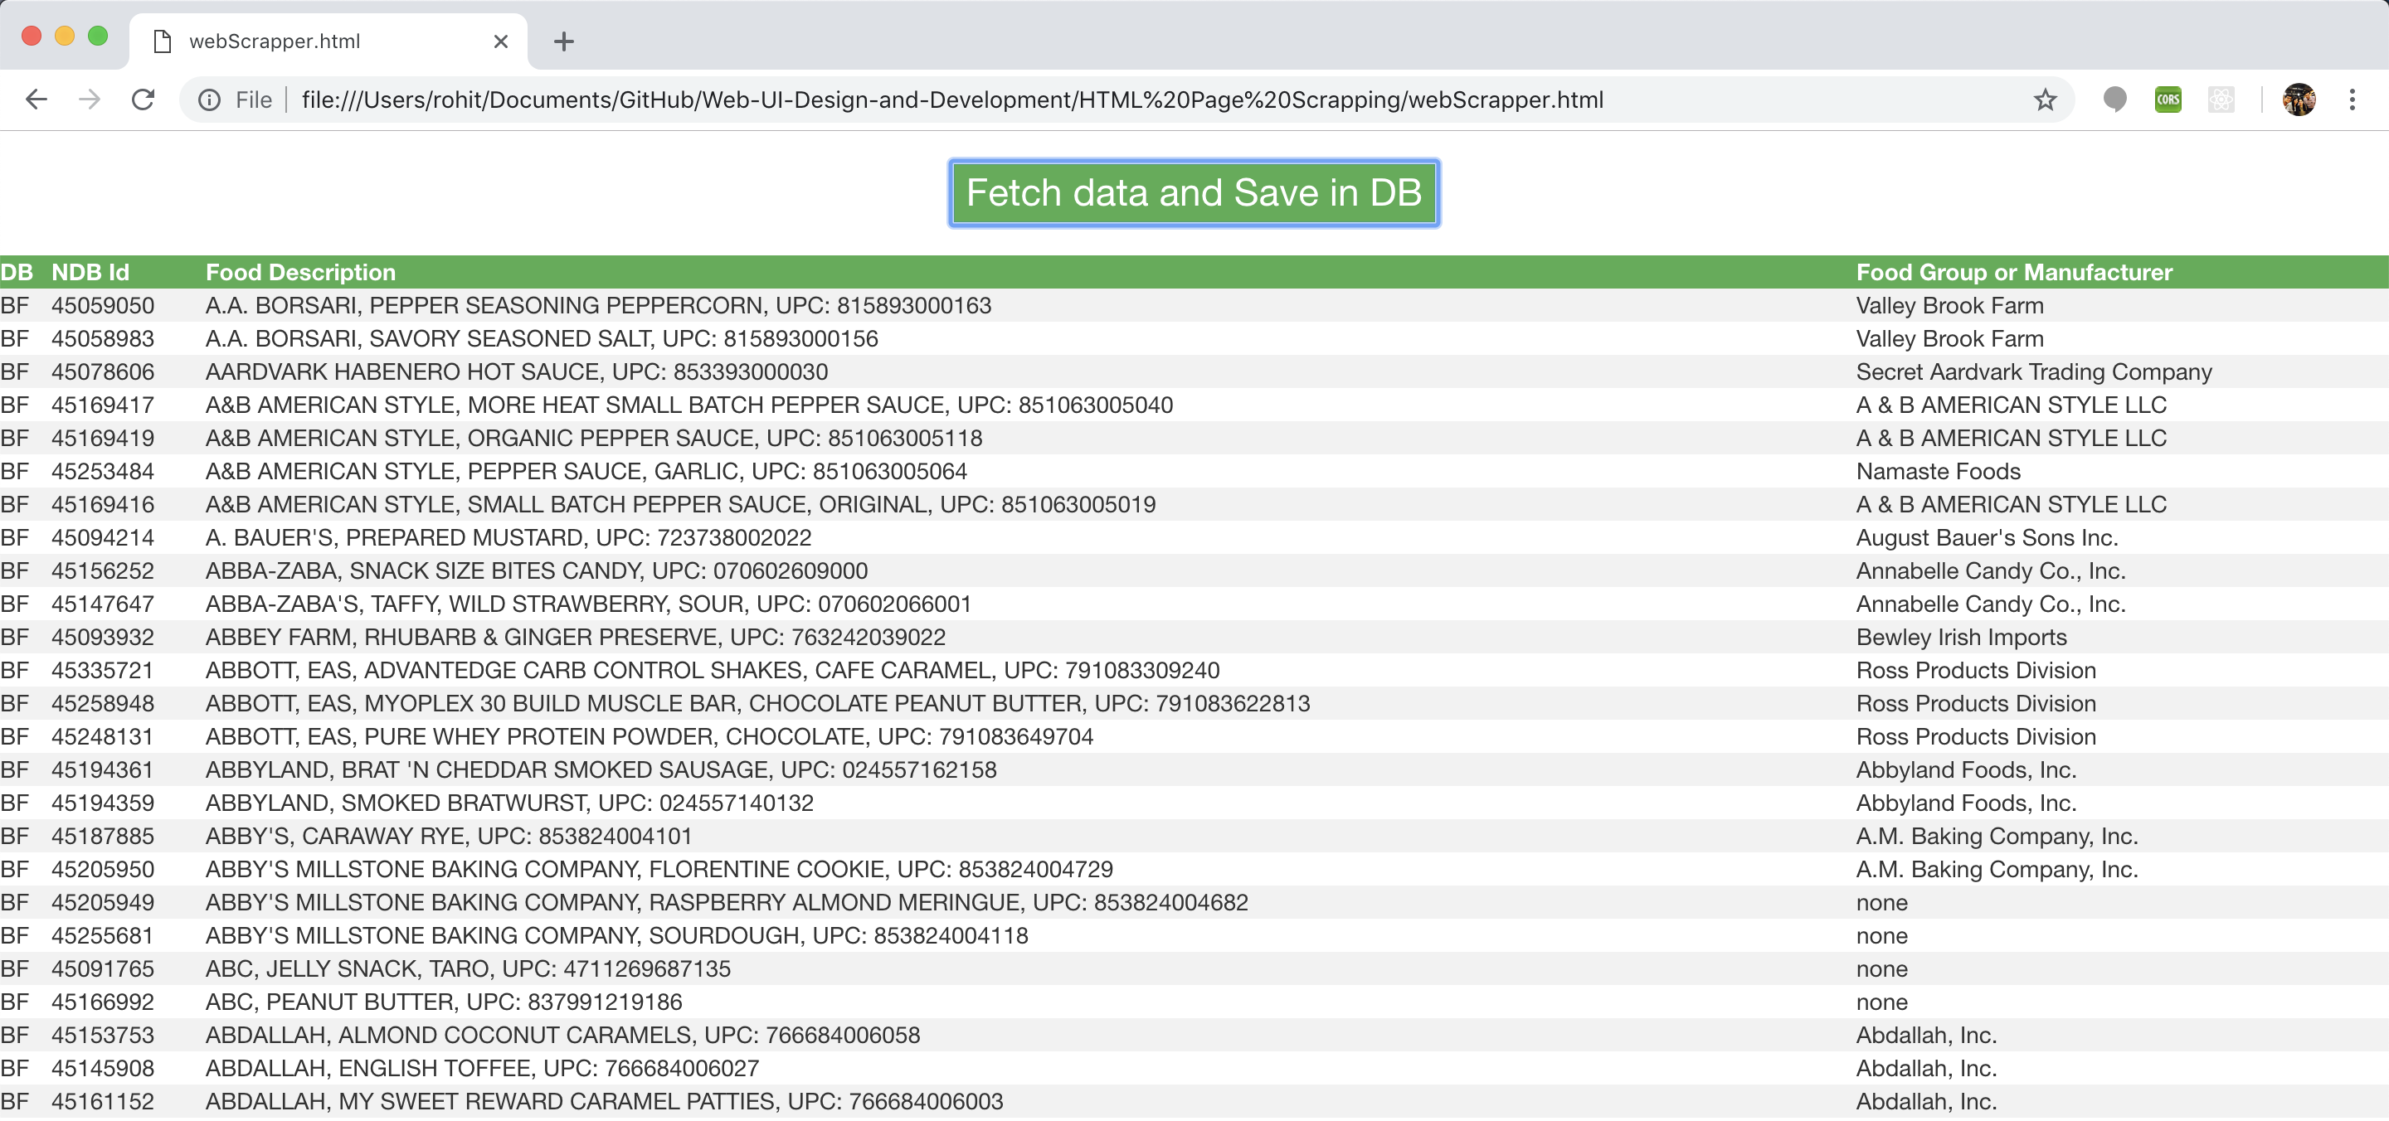

**Data inserted in DB:**

